**Othm**

**( operation task’s helping machine )**

**---------------------------------------------------------------------------------------**

**Tkinter**

It is a standard Python library used for creating Graphical User Interfaces (GUIs). It provides a set of tools and widgets (such as buttons, labels, text boxes, and menus) that help developers build windows-based applications with a graphical interface, as opposed to command-line programs.

**Repository :**

The codebase is completely updated on the github id : “https://github.com/U4RAD9” , with the repo name as “Merging Software”.

**How To Run the Program :**

* You just need to clone the repo “Merging Software”.
* Their is no particular environment required for it, there are some basic libraries, that you can simply add.
* Once you clone , go to the directory where the file “merge_pdfs.py” is present.
* Open the directory in your preferred code editor.
* Run the program using “python merge_pdfs.py” or “py merge_pdfs.py” .

**How to Create the Exe :**

* Their will be a file named “merge_pdfs.spec”.
* This file contains the logic to create the exe from our python program.
* You just need to change the name of the software in it “name='HimanshuMergingSoftware(V5)’, ”.
* Everytime a new version is created, just update the version here and use accordingly.
* Once, you run the command the created exe will be stored in the directory named “dist” .
* Command to create the exe : “pyinstaller merge_pdfs.spec” .

**README.md File :**

In this file, mainly i’ve written one to one updates, giving a basic understanding step by step, that what work is done when.

**OTHM**

This is our main s/w, once you click the “HimanshuMergingSoftware(V$).exe” or when you run the “merge_pdfs.py” file, than you will see this frontend to interact with our OTHM or Merging Software.

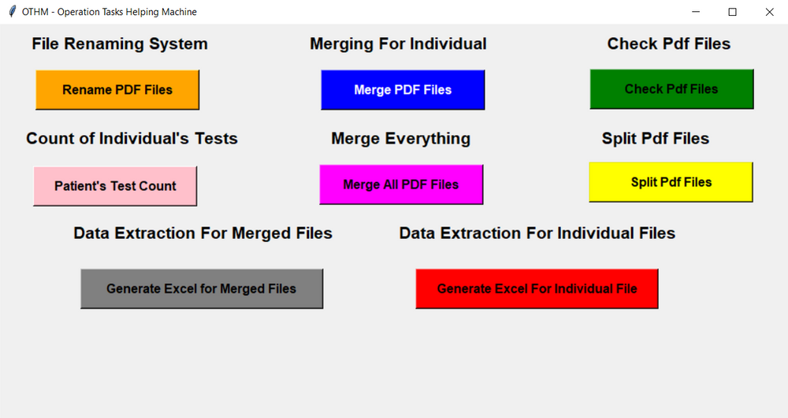

**Tkinter Window :**

I have used the window given by the Tkinter library to create this frontend to interact with the user, where simply i have used it’s labels and buttons to make it more interactive.

**NOTE: I can simply add more labels and buttons here and add the respective function to make new automation things in it.**

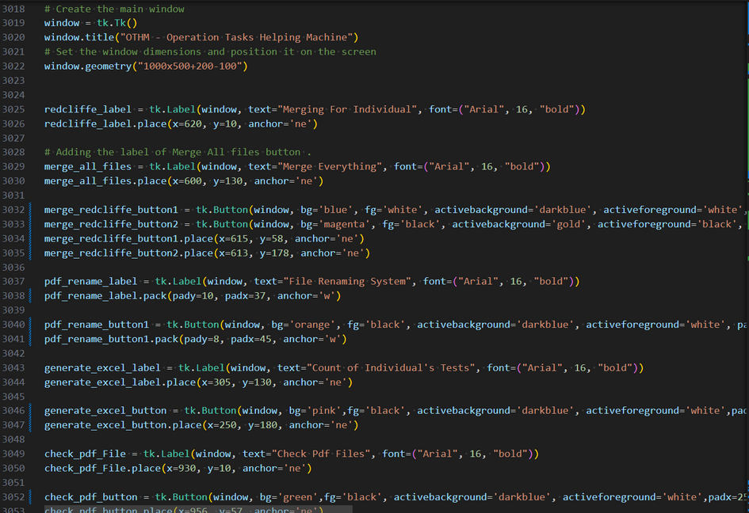

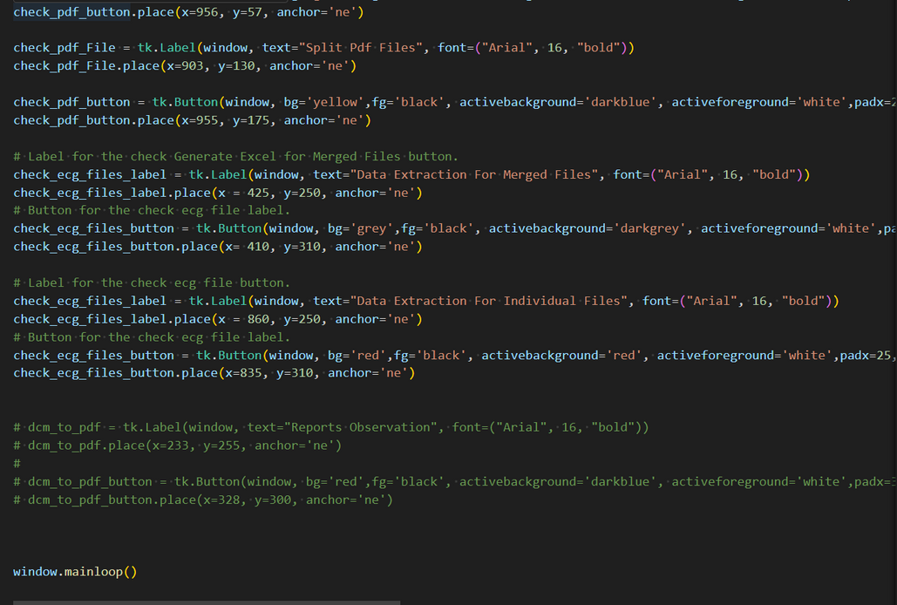

**LIST OF LIBRARIES :**

• **os**: For interacting with the operating system, such as file and directory manipulation.   
• **os.path**: For manipulating file paths and working with file system paths.   
• **pathlib**: For handling file and directory paths in an object-oriented way.   
• **PyPDF2**: For reading, merging, and manipulating PDF files.   
• **tkinter.filedialog**: For providing file dialog boxes to allow users to select files or directories.   
• **tkinter.messagebox**: For displaying message boxes to the user for alerts, warnings, or confirmations.   
• **PdfMerger (from PyPDF2)**: For merging multiple PDF files into one.   
• **PdfReader (from PyPDF2)**: For reading PDF files.   
• **PdfWriter (from PyPDF2)**: For writing or creating PDF files.   
• **re**: For working with regular expressions, used for string searching and manipulation.   
• **time**: For working with time-related functions, such as delays or timestamp generation.   
• **shutil**: For file operations, such as copying and moving files.   
• **openpyxl**: For reading and writing Excel (.xlsx) files.   
• **PIL (Python Imaging Library)**: For image processing tasks such as opening, editing, and saving image files.   
• **pytesseract**: For Optical Character Recognition (OCR), extracting text from images.   
• **fitz (from PyMuPDF)**: For working with PDF documents, extracting text, images, and more.   
• **openpyxl.styles**: For styling Excel files (e.g., setting font styles and cell colors).   
• **openpyxl.Workbook**: For creating new Excel workbooks.   
• **pandas**: For data manipulation and analysis, particularly with structured data like tables (DataFrames).   
• **ThreadPoolExecutor (from concurrent.futures)**: For parallel execution of functions using threads, enabling faster processing for concurrent tasks.   
• **math**: For performing mathematical functions, such as trigonometry, logarithms, and more.   
• **reportlab.pdfgen.canvas**: For creating PDF documents programmatically.   
• **reportlab.lib.pagesizes**: For setting the page size of PDFs, such as letter, A4, etc.   
• **datetime**: For working with date and time operations, including formatting, manipulation, and comparisons.   
• **warnings**: For managing warning messages in Python, to suppress or raise specific warnings.

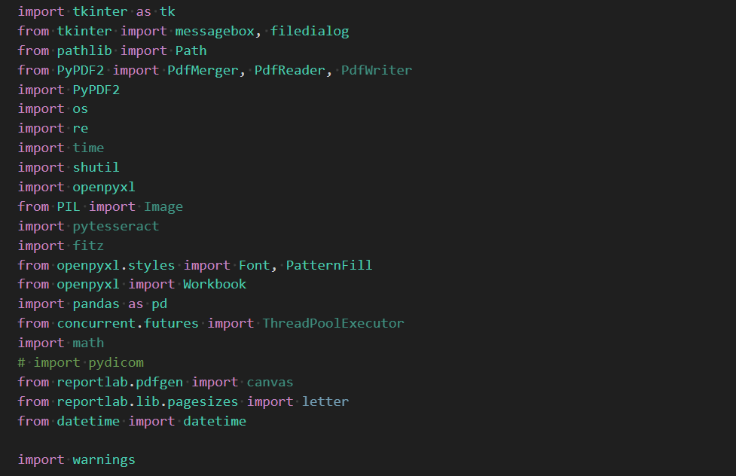

Now, let’s see the HELPER FUNCTIONS that i have created to reduce the boiler plate codes :

* Helper for printing the logging :

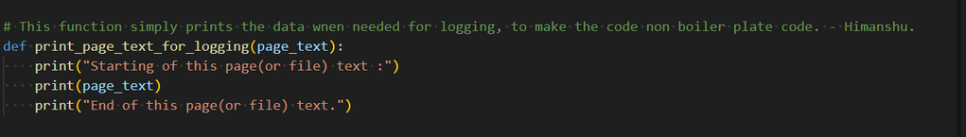

* Creating the patient details and the patient data dictionary :

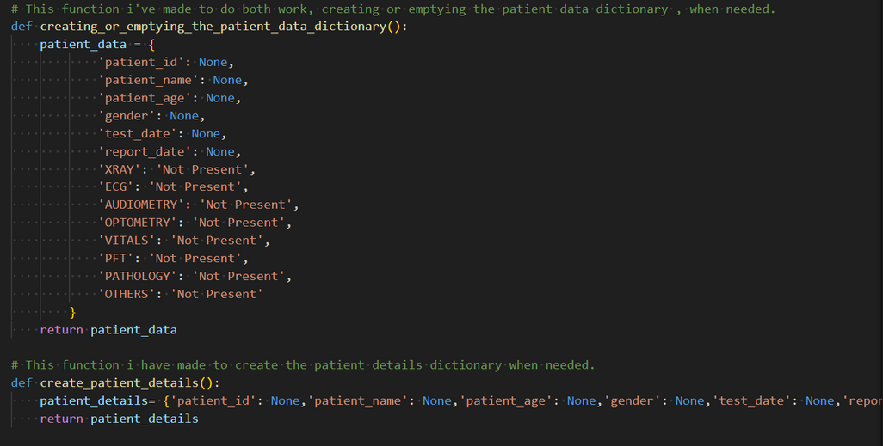

* To make the user select the input folder and the output folder , so that he/she can give us the directory where files are present that needs to be processed, and the output directory where they want the results after processing :

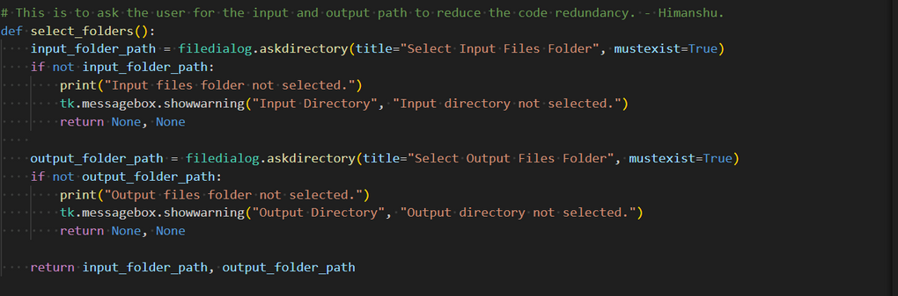

* This function maps each and every respective modality data extractor function that extracts the data from the file based on what type of file it is :

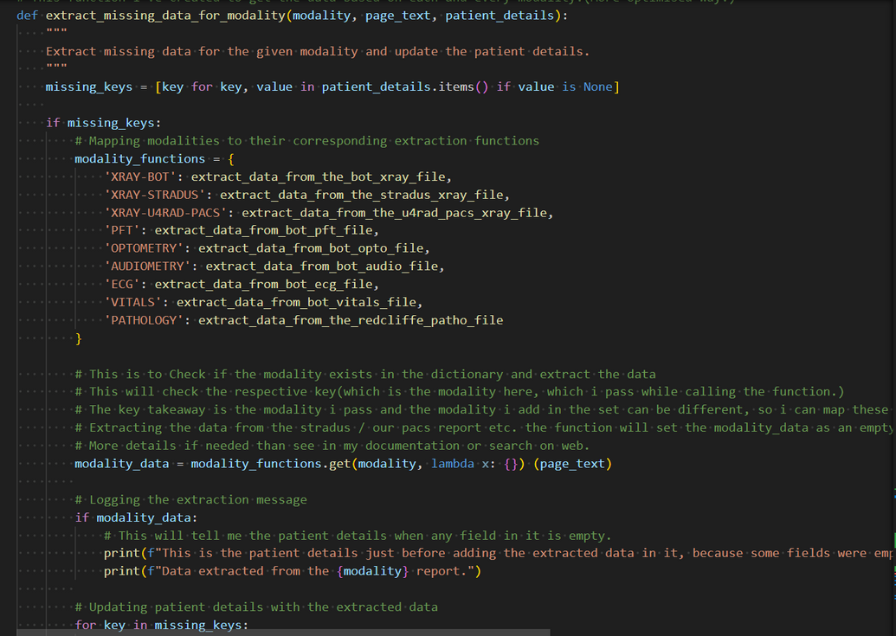

* This gives separate excel workbook’s based on the modality it is :

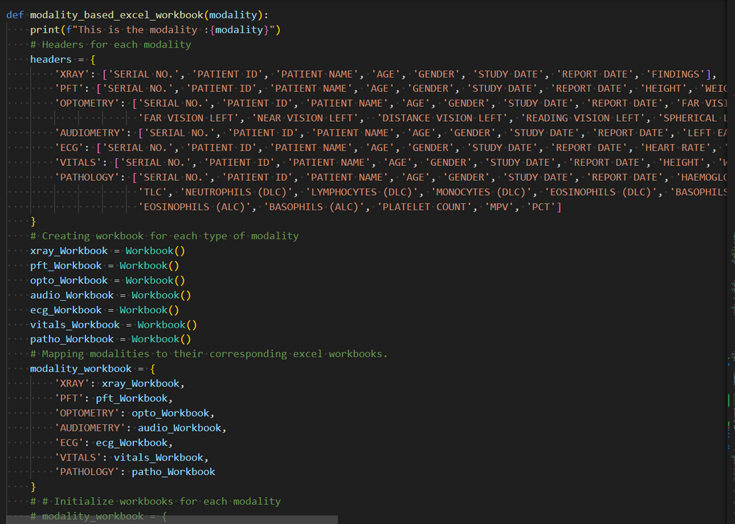

The above helper functions are some of the basic ones that are used to simplify the task to some extent.

**Important Helper Functions :**

These are some of the important functions that provide data based on the type of report is present in it.

* Each report is having a fixed type of format.
* If it is a xray file , than there are three types of files : Report generated by our Reporting Bot , Report generated by Stradus, and the Report generated by our U4RAD PACS Bot.
* Mostly, the pathology files are present from the Redcliffe Blood Reports, so I’ve extracted the data as per the data i am extracting from that file.
* Also, I am extracting data from similar files like Vitals Report, Optometry Report, Audiometry Report, ECG Report ,and PFT Report.
* Doctor Consultation file is a simple image getting appended in the reports, so i can’t extract any data from it.
* Smart Report is mostly a image (but sometimes a extractable file , not created any function to extract data from it yet.) , so i can’t extract any data from it too.

**All Important Functionality Helpers :**

* Function to categorise the reports in terms of modality and then use the proper functions to extract their data too :

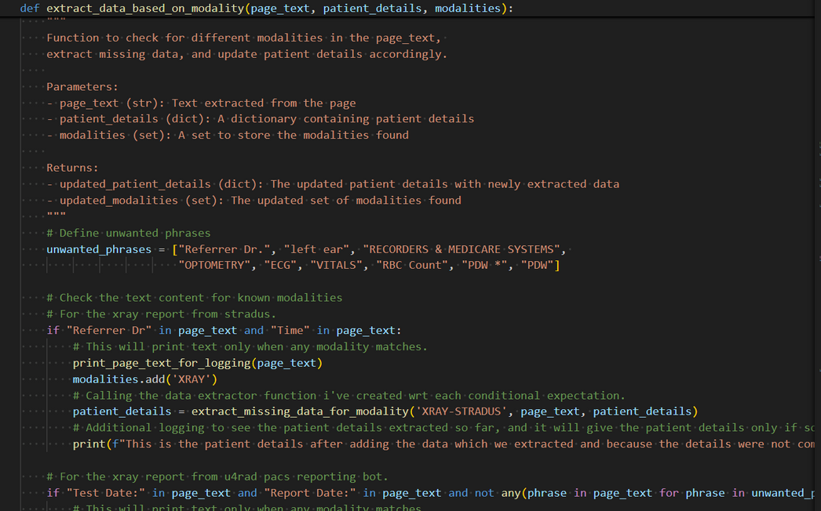

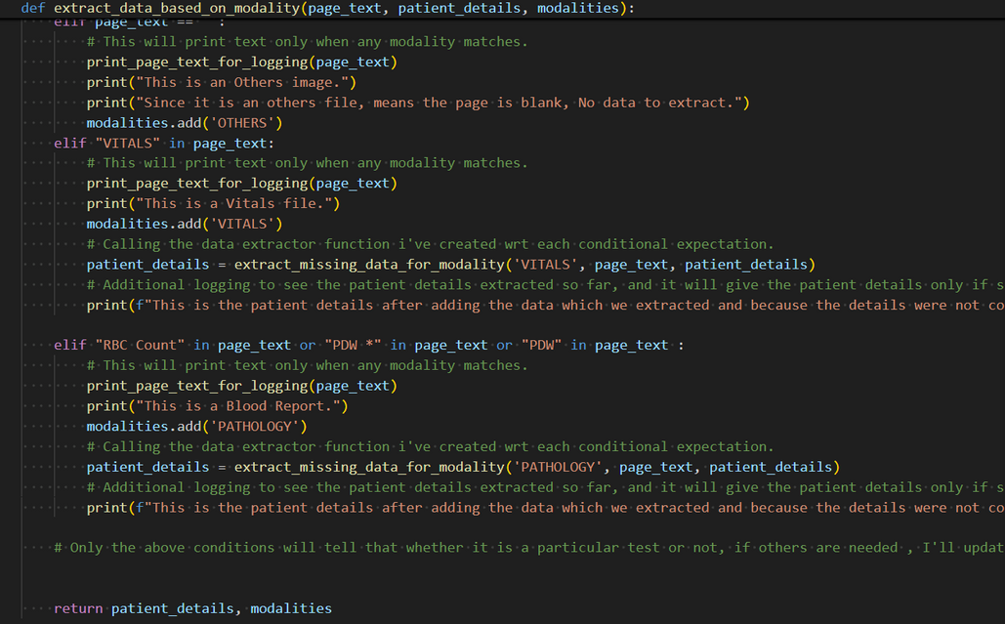

* Function to extract the data from all the pft files :

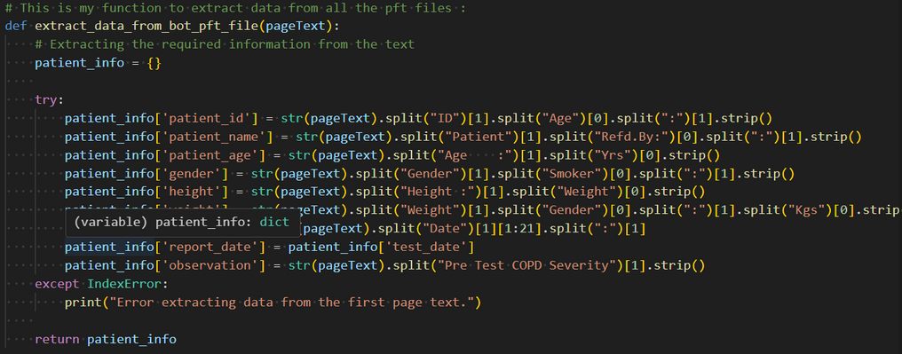

* Function to extract all the ECG Files :

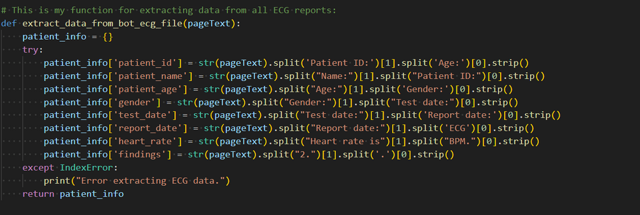

* Now, this function is completely dependent on the Redcliffe files.
* **Note : I am writing this in prior that REDCLIFFE’s Blood Reports are always with some format change. So Each time you face any error, add those formats too in the extraction logic (Without removing the previous logic) .**
* This is the function to extract the data from the Pathology (Blood) Reports :

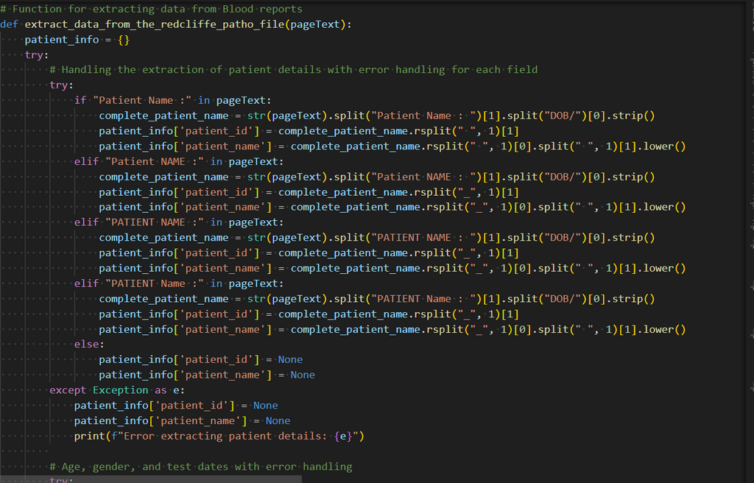

* To extract data from the Audiometry Reports :

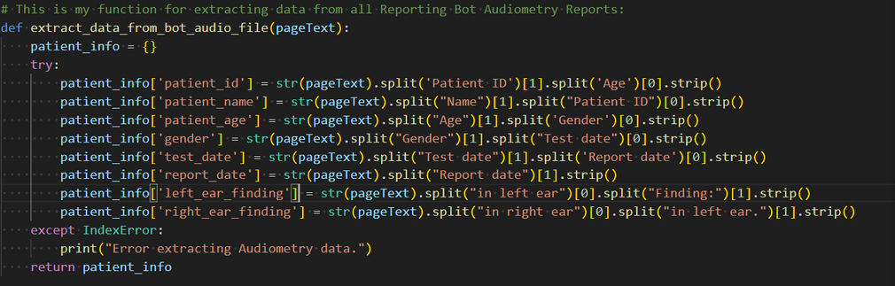

* To extract data from Optometry Reports :

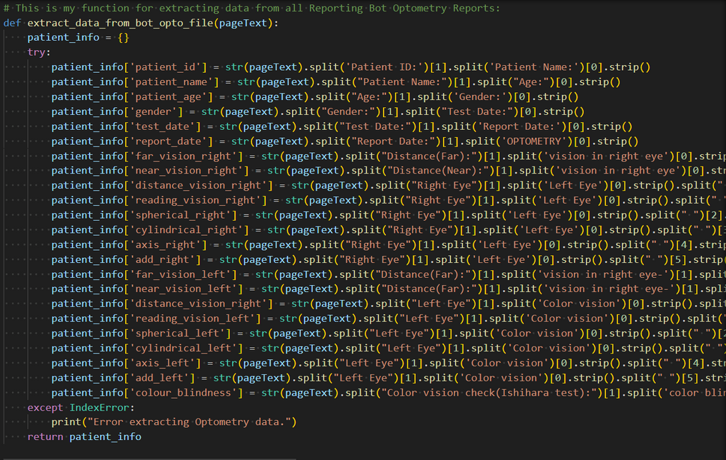

* To extract data from Vitals Reports :

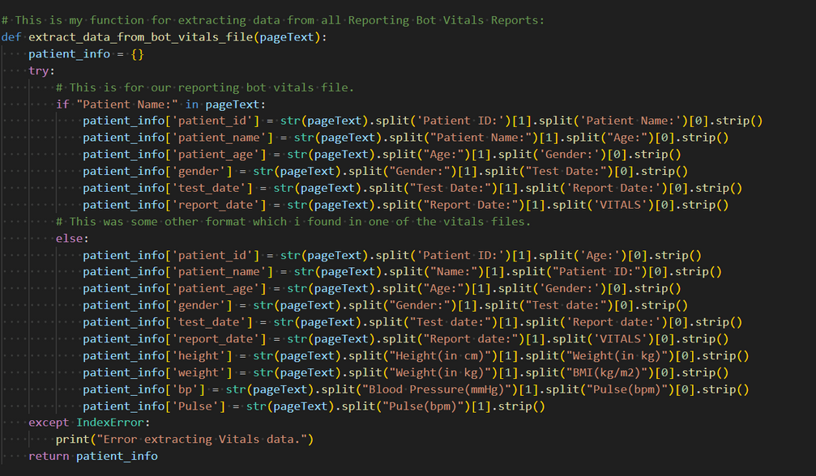

**Most Important**

Now, these are the three important types of data extractions, these are all XRAY Report Data Extraction function , but one is for our Reporting Bot , one for Stradus Reports and the last for our U4RAD Orthanc Pacs Reports.

* Our Reporting Bot Xray Report Data Extraction function :

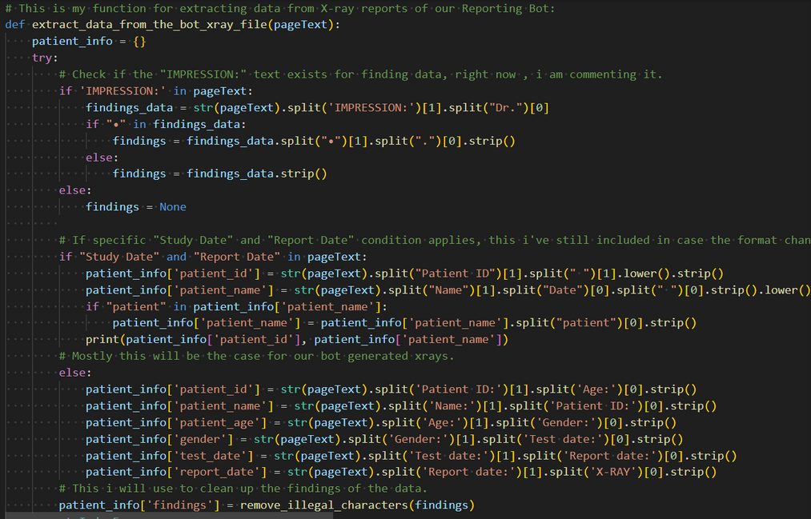

* Our Stradus Xray Report Data Extraction Function :

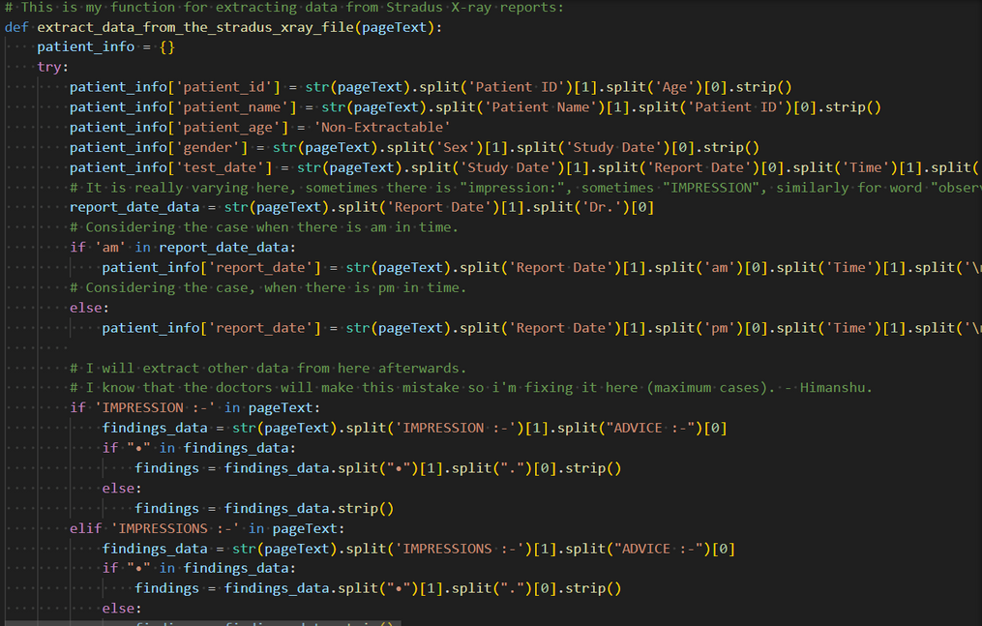

* Our U4RAD Orthanc Pacs Report Data Extraction Function :

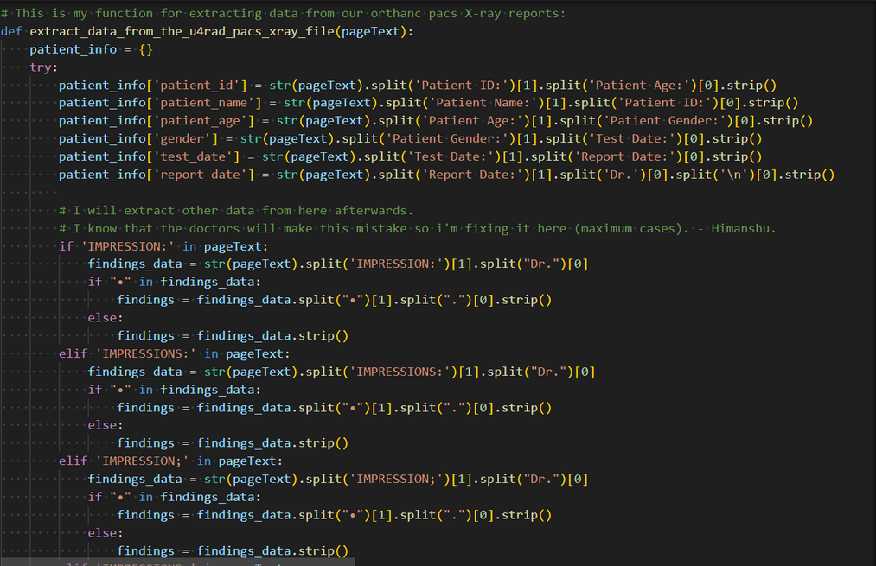

**ERROR HANDLING :**

* Mostly I am using all the try-catch functionalities here , so there are less chances of facing any errors or getting into any exceptions.
* Also , When processing multiple files, there are a no. of errors like :

1. Sometimes, the same file is getting copied again and that’s why it is completely redundant to process them as per our need, so I simply add them in the category of **Duplicate Files.**
2. I have given a fixed format to the Operations team for each and every file to be processed, i.e. the file should always be in the format of “**Id_Name**“ . Now, if any file does not follow this format and use any unnecessary structures like having ‘.’ , ‘-’ etc. then I’ve categorised these files in **Naming Error Files** .
3. Now, Most of the files have these issues that the ‘Id’ present in the Filename and the id that i am extracting from the File, are not matching, so I’ve categorised them in **Id Mismatch Files** .
4. Now, If in case any of the field is left empty than I’ve categorised them as **Incomplete Data Files** .
5. And, atlast if there are any exception files than they are present in the **Exception Files** section.

* All the above errors , if present, than are added to thier respective Error folder , the Folder is named after the type of Error.
* And all type of errors are also added to a Error File , which is a text file, which stores all the details of the errors (if experienced / present) while processing the files.
* This is the function that adds the files to the respective folders and creates the Error File iff any error occured :

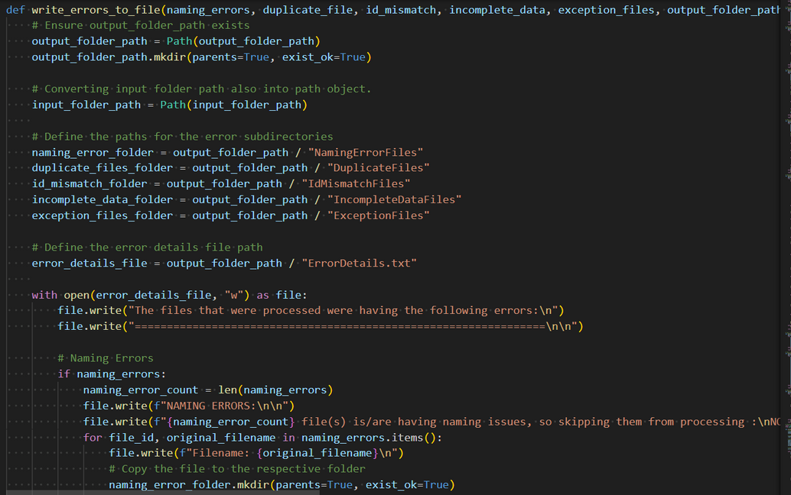

* This function displays the warning message based on the errors iff occured :

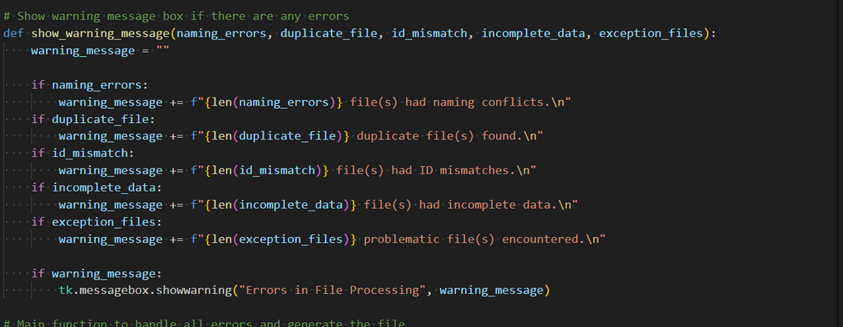

* And , this is the main function that handles all these errors :

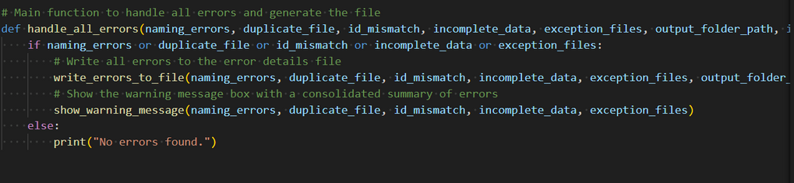

**BASIC WORKFLOW :**

Now , mostly these are the basic workflow for each and every task you want our OTHM to perform :

**Asking For the Input Directory :**

* Here, you will select the directory in which all the files are present that you want to process, or on those, you want to operate your required tasks.
* Just selecting the name is enough (No need to open the folder).

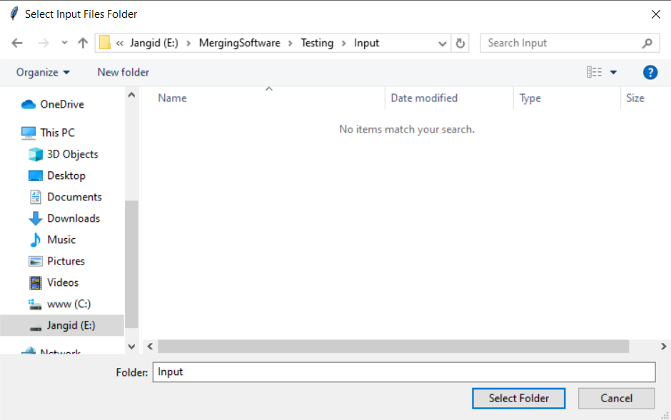

**Asking For the Output Directory :**

* Here, you are specifying that where you want your task / operation / processed results to be stored.
* Here also, just selecting the folder is enough, No need to open it.

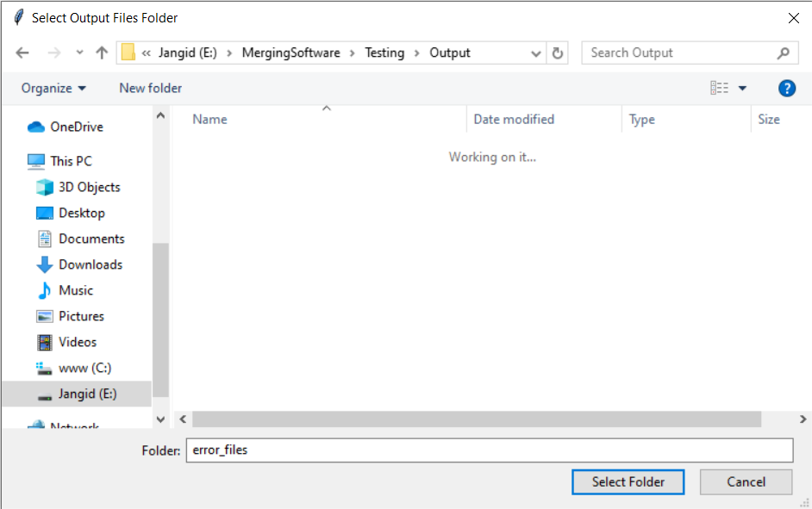

**Asking For the Excel Directory (iff any excel is present that is needed) :**

* Here, you have to select the excel file that you want to use in processing.
* Here, just clicking on the folder won’t be enough , You have to select the particular excel sheet that you want to use.

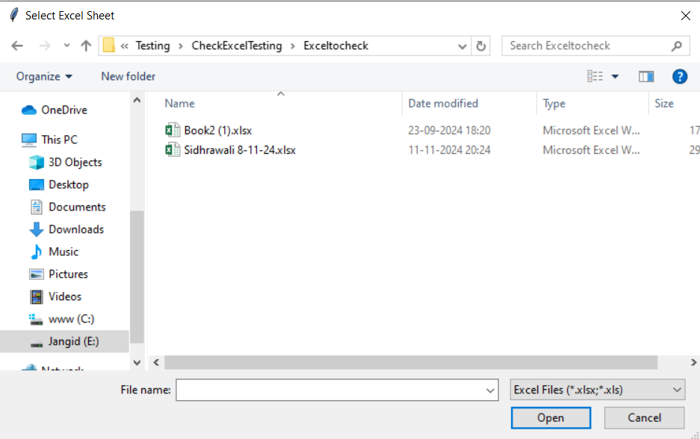

**INDIVIDUAL TASKS / OPERATIONS :**

**Rename Pdf Files**

* This function renames all the files in terms of our desired format, i.e. ‘ ID_Name*’ format.
* There can be other things too here like institution name etc. based on the requirements.

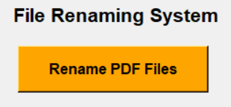

* Just click on the above button, it will ask for the Input and Output Directory.
* In the input directory add all the files in whatever format they are.
* Give the output directory where you want your results to be.
* **Functionality Working :**
  + The function will read the pdf files one by one.
  + It will identify the kind of report it is i.e. whether xray, ecg , pft etc.
  + Based on the type of report there are certain extraction conditions and techniques I’ve used which extracts / splits / separates mainly two things from the extracted complete text data , which is ‘ Patient ID ’ and ‘ Patient Name ’.
  + Now, each file is renamed with the respective names as ‘ Patient ID_Patient Name ’ where these two are already extracted based on the modalities.

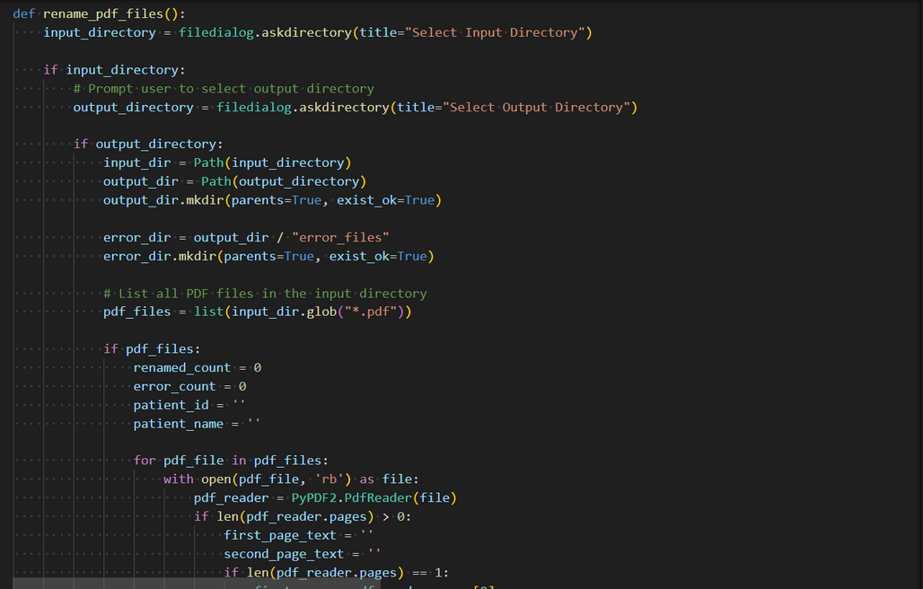

**Merge Pdf Files**

* This function accepts all the files in this format only ‘ ID_Name ’ i.e. there should be atleast an ID and a Name in the filename , both separated by the first underscore ( *_* ) in it.

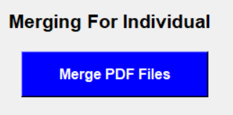

* Just click on the above button, it will ask for the Input and Output Directory.
* In the input directory add all the files in the format it is asked i.e. ‘ ID_Name’ .
* Give the output directory where you want your results to be.
* **Note :**
  + - I am converting each and every id in lowercase, So if the Operations Team by mistake write the unique Id in filename in UpperCase, then also , no need to worry , it will read it in lowercase (until unless all the characters are same (otherwise id mismatch)).
* **Functionality Working :**
  + Here, all type of reports are present of different patients altogether i.e. for a particular patient let’s say if it has pft report, xray report , ecg report etc. than all of these are present here in the same directory.
  + Now, the function takes all the files that are having same id, and merges thier files in a single one.
  + It arranges them in a fixed format, by first identifying that which kind (type of modality) of report it is.
  + Then it does the same for each patient i.e. each unique id.

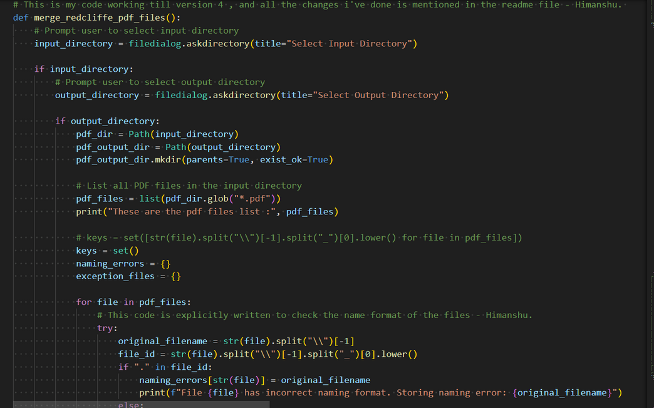

**Check Pdf Files**

* This function accepts all the files in this format only ‘ ID_Name ’ i.e. there should be atleast an ID and a Name in the filename , both separated by the first underscore ( *_* ) in it.
* **This function checks that for a particular patient, what reports/tests are done and what is the issue/errors ( iff any ) ( id mismatch, name mismatch, etc. ) in the respective patient test reports.**

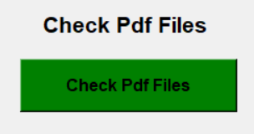

* When clicked, it will ask for the I/P Directory and O/P Directory as always.
* It will also ask another thing, which is the excel file (using which the comparison needs to be done).
* **Note :**
  + - This separate file will be prepared by the Operations Team.
    - The user must select the excel sheet that needs to be used ( **not the directory only** ), otherwise it will throw an error.
    - Only ‘.xlsx’ and ‘.xls’ file types are allowed.
* **Functionality Working :**
  + I’ve created a modality match list, which stores the type of modalities any particular patient is having i.e. the tests that are done by a particular patient.
  + Created a excel sheet with some **Fixed Headers** ( name, age, gender, id , study date/test date and report date) **(Note : Each time in this documentation the fixed headers will correspond to these 6)** and alongwith that 7 cell headers representing all the type of test reports we do (except Doctor Consultation) and 1 header representing the Problem list.
  + If any patient file contains the respective modality then for that particular patient it is marked as ‘Yes’ in the respective modality cell , else ‘NO’ .
  + I’m also changing the color of the cell for more easy identity, making ‘Yes’ to green and ‘No’ to Red.
  + **No worries for the casing of patient id and name, here also , because i am processing all as lowercase here too.**
  + All the exceptions are handled correctly.
  + It in final give the result in the form of a excel sheet.

**Count of Individual Tests**

* This function gives the count of patient tests.
* It is logically separate from the Check PDF Files ( if someone’s thinking of similarity), as it doesn’t need any excel file to compare with.
* You just give the files to it and it gives the individual tests in the form of excel sheet in the end.

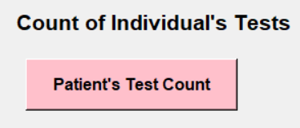

* **Important :**
  + - **I have created another tkinter window here, which asks for the type of files you need to process, as the logic is separate for both.**
    - **It asks either you want to process ‘All the individual files for any patient’ OR ‘All the Merged Files Of Patients’.**

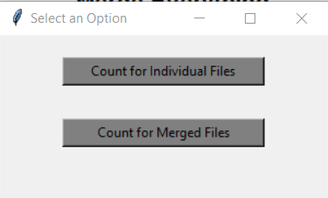

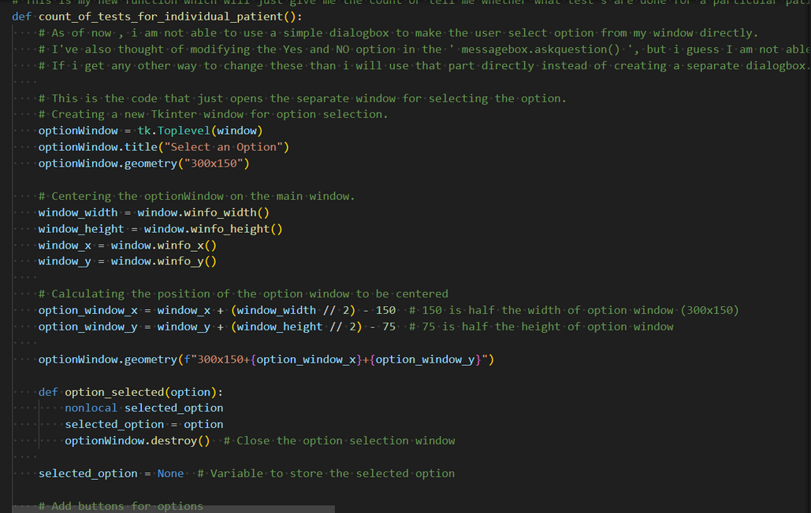

* **Note :**
  + - In this function I am completely making use of the Helper Functions (because from this functionality onwards, I’ve created the Helper’s).
    - Most probably I’ve left the created data structures to the hands of the Python Garbage Collector.
    - Since, I am using a ‘.exe’ so , when closed, it will automatically remove all the created data structures.
    - **The above Data Structure Handling needs to be optimized.**
* **Functionality Working :**
  + It will first ask for the option selection when clicked.
  + As per the selection it will further process the logic.
  + It asks for the I/P and O/P directory before.
  + It creates some things before proceeding selected option wise, as it is common for both the options like making the keys set , error handling dictionaries, respective headers etc.

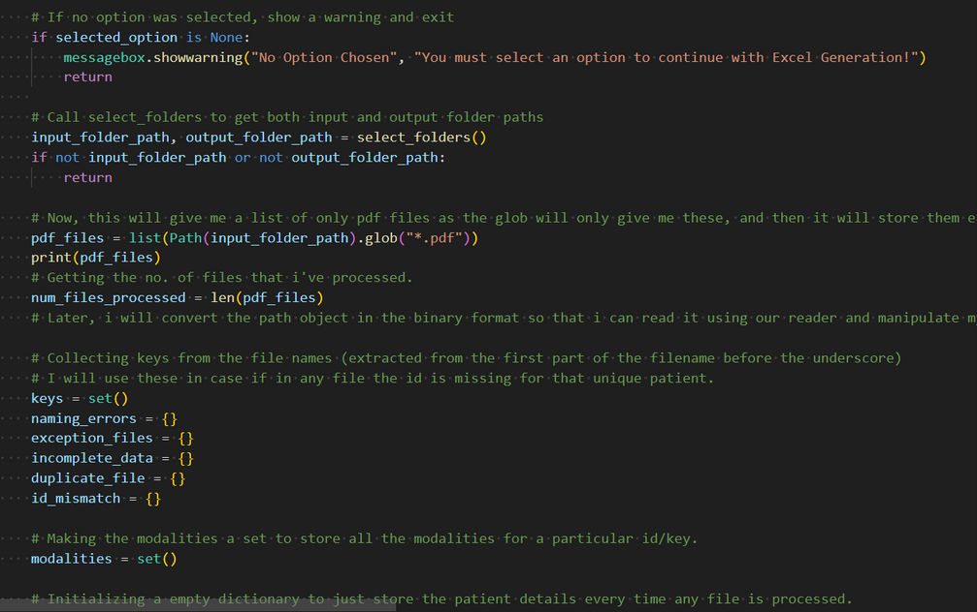

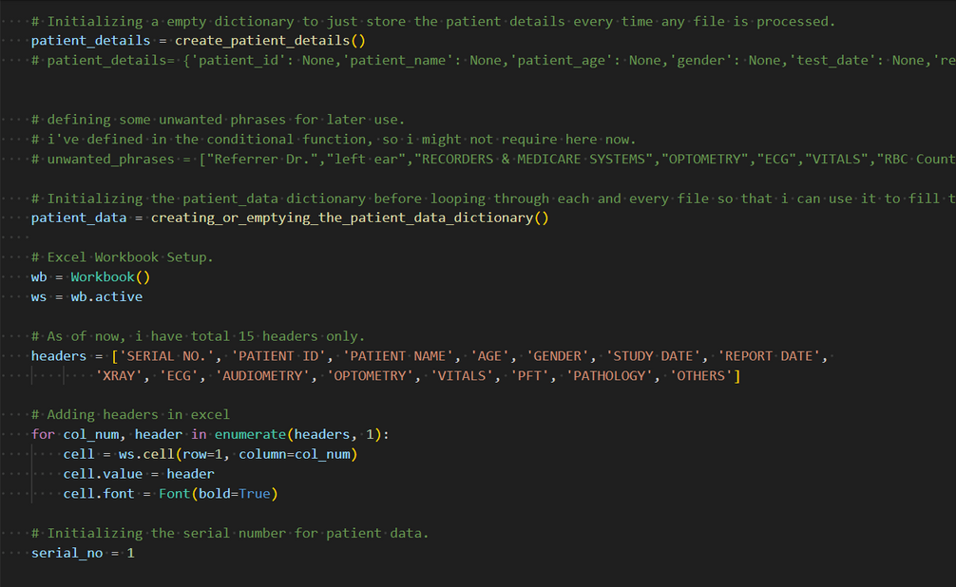

* + If Option 1 is selected i.e. **Count For Individual Files** :
    - It then process files one by one.
    - If any file id is new i.e. not yet processed, than it adds the file_id to the keys, and creates a patient_details dictionary and a modalities set for that particular key.
    - If any file processed again , matches the key present in keys set, than instead of creating new dictionaries and modalities, it just uses the last created one and appends the data to the same accordingly.
    - Here I have used mostly all the helpers in a creatively optimal way (Much details I expect the new developer to understand from the code 😄 )
    - All the errors are handled by the helper function.
  + If Option 2 is selected i.e. **Count For Merged Files** :
    - It also processes the files one by one.
    - As the merged file itself has all the type of reports, than the logic is much easier here.
    - It checks the file_id and then appends it to the keys.
    - Processes each page one by one, if modality matches than adds to the modalities set.
    - Once a file is processed than it clears the modalities and the patient_data.
  + Common For Both :
    - For both the error handling function is same.
    - The output is a excel sheet containing the basic **Fixed Headers** and the names of each Modality ( all 8 types ) in the next cells, along with the Serial No’s too.
    - If any modality is present than it gets marked with ‘Present’ with Green cell colour , if not then ‘Not Present’ with Red cell color.
  + **Note :**
    - **The key note here is that it also extracts the Fixed Header data from the files.**
    - **But making optimisation, I’ve created one thing if the respective modality is identified and Fixed Headers are already extracted from one than it doesn’t need to extract again in the next modality identification.**

**Merge Everthing**

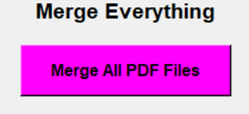

* It just merges each pdf file you give it, one by one, in the order they are present in the directory.
* Just give the I/P and O/P directory, and get the expected results.

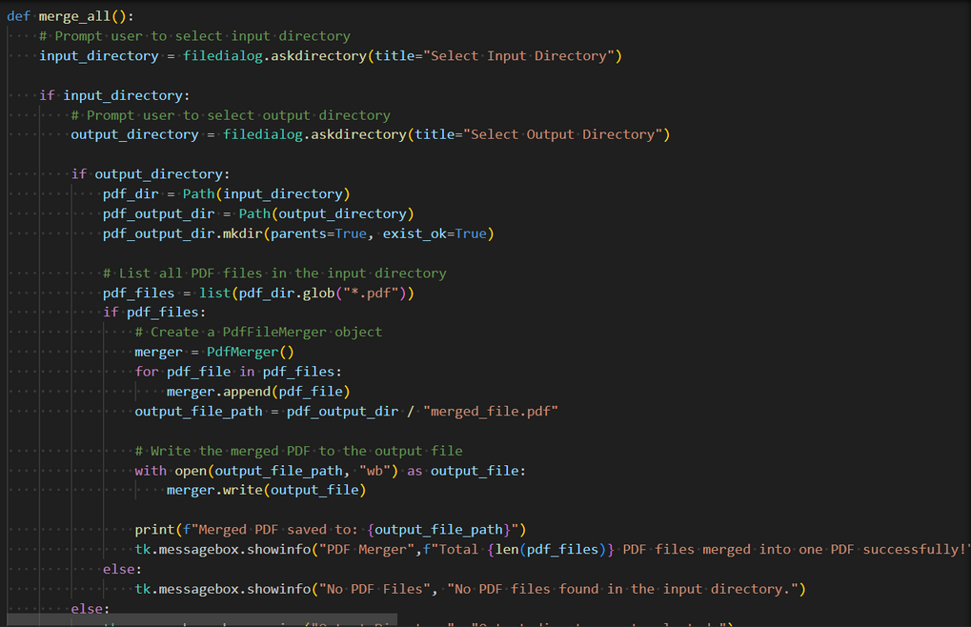

**Split Pdf Files**

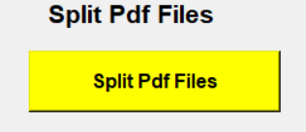

* It does just opposite of the Merge Everything.
* It gives any file given separated in individual pages.
* **Note :**
  + It can be optimised in a way that it splits the files in individual modality reports.

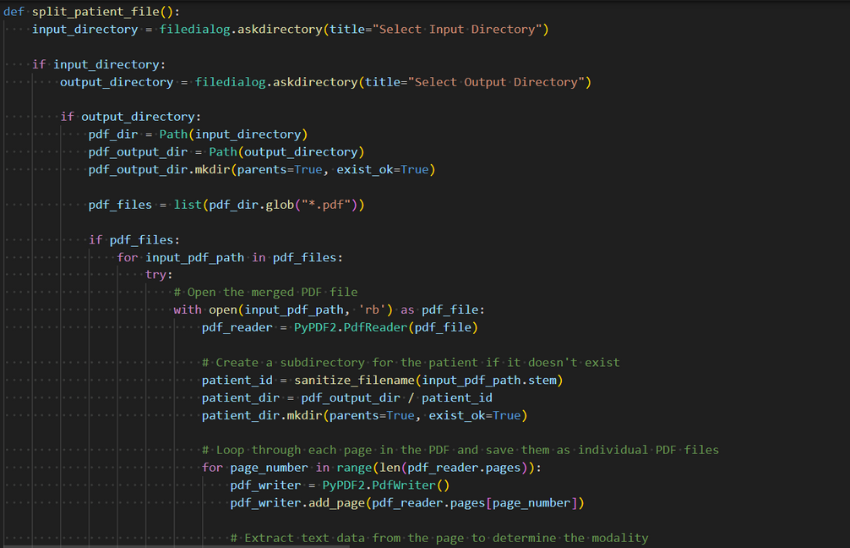

**Generate Excel For Merged Files**

* It gives each modality separated data in forms of excel sheets.
* For example if there are multiple patients then if we need separate excels like the patients data who did Xray Test, Optometry Test , and similarly remaining.
* Than based on the modalities present it appends data to the respective excel , Ex. if Audiometry report than it gets appended to the Audiometry Excel.

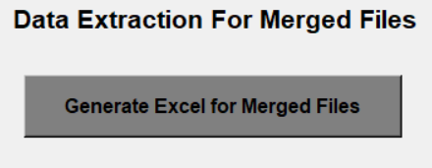

* **Note :**
  + - In this function I am completely making use of the Helper Functions .
    - I’ve created a dictionary which provides the respective excel sheet accordingly.
    - **For the next developer, test it again and fix the logic a bit for much optimal results.**
* **Functionality Working :**
  + All the basic things are present, as similar to the count of tests functionality.
  + It processes the files one by one, just checks the type of modality.
  + And also checks whether the same id is already appended to the respective excel, if yes than skips it.
  + All the error handling are similar.

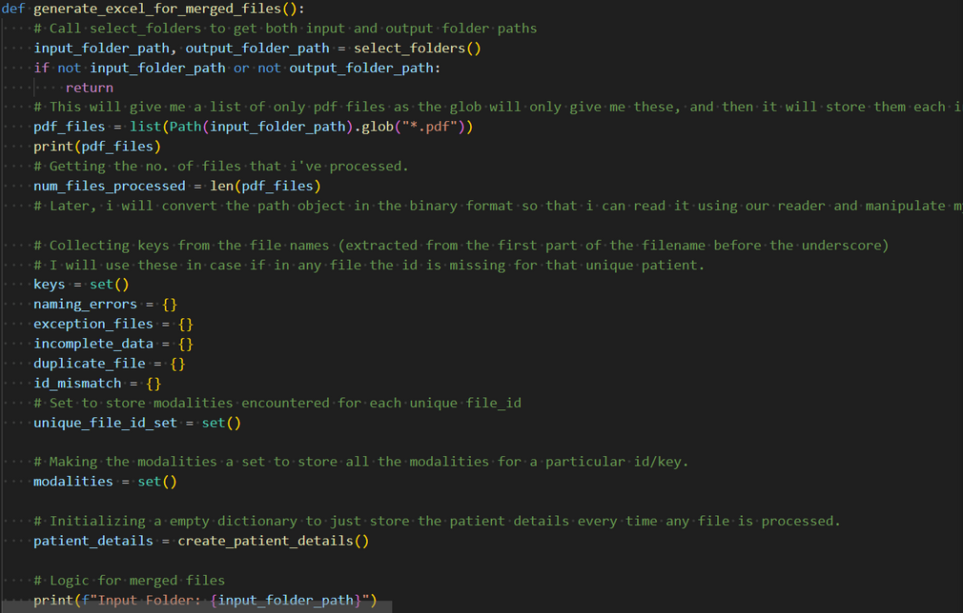

**Generate Excel For Individual Files**

* It also gives each modality separated data in forms of excel sheets.
* Just the difference is we give non merged files here (As the name suggests).

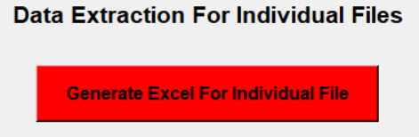

* **Note :**
  + - In this function I am **not at all** making use of the Helper Functions .
    - I’ve just altered the previous logic.
    - This has completely boiler plate codes, that can be easily optimised.
    - **It appends the data irrespective of the case that either it is already appended or not.**
* **Functionality Working :**
  + It gets the input directory files , and then processes them one by one.
  + Mostly the files are single page and double page, so if it is single page than it passes the first page data as it is.
  + If it is having 2 pages ,than it passes the second page.
  + And if more than 2 pages, then the first page is passed , and all the logic is created accordingly.
  + It checks the type of modality , altogether extracts the required details , and update the respective modality count from 0 .
  + If any modality count is greater than 0, than creates/appends the respective data to the respective excel.
  + **No proper error handling like in others , Definitely needs to be optimised.**

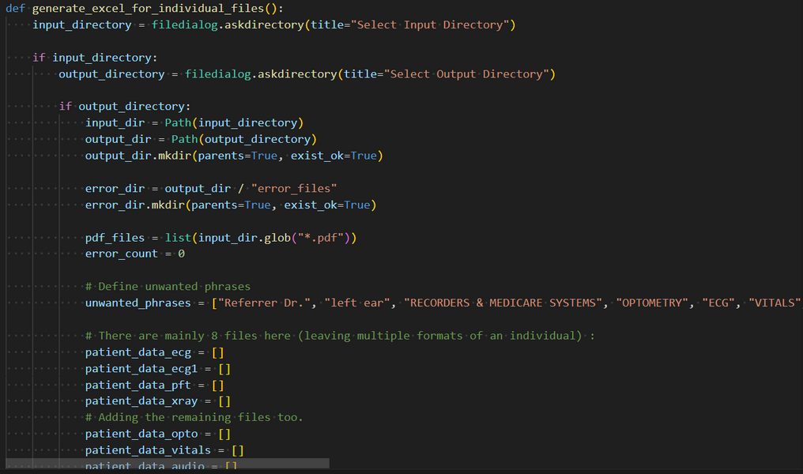

**OPTIMISATIONS**

1. **The code contains a lot of Boiler Plate (Redundant) Codes, so make it more optimised.**
2. **The Helper Functions I’ve created are not used in all the functions, so use it in other functions too for much smoother workflow.**
3. **Introduce the Error Handling in other functionalities too as I’ve developed for the Test Count Function or Generate excel functionality.**
4. **Handle all the data structures created in proper way, so we can increase the speed of the workflow ( Make proper use of the Garbage Collector ).**
5. **Mostly, the Operation Team introduces new formats of the pdf’s , so just append the respective format to the respective functionalities, instead of removing the previous ones.**
6. **Most of the functionality logics are stucking in unnecessary loop or processing. Identify those and fix them.**
7. **Introduce more Error Handles, so that the tasks are more brief and helpful.**
8. **Introduce ways to append the Doctor Consulation, Smart Reports etc. too.**
9. **Make sure to handle each and every exception so that no Operation Member face any type of Fucntionality Error.**
10. **Optimise the code in every possible way, a lot of efficient modifications are needed here.**

**End of page.**

**All the Best for Future Development .........**